

**SCHOOL OF COMPUTING**

**GRAPHIC ERA HILL UNIVERSITY, BHIMTAL CAMPUS**

**2023-24**

A

Term-Work

On

**Full Stack Development Lab(PMC-101)**

Submitted in partial fulfillment of the requirement for the I semester

**M.C.A**

By

**Lalit Singh**

**237112182**

**…**

**Faculty-in-Charge**

**Mr. Devendra Singh**

**Associate Professor**



**SCHOOL OF COMPUTING**

**GRAPHIC ERA HILL UNIVERSITY, BHIMTAL CAMPUS**

**2023-24**

**STUDENT’S DECLARATION**

I **Lalit Singh** hereby declare the work, which is being presented in the term-work, entitled “Full Stack Development Lab” in partial fulfillment of the requirement for the award of the degree **M.C.A** in the session **2023-2024**, is an authentic record of my own work carried out under the supervision of

**Mr. Devendra Singh.**

The matter embodied in this term-work has not been submitted by me for the award of any other degree.

Date: ………… (Full signature of student)



**SCHOOL OF COMPUTING**

**GRAPHIC ERA HILL UNIVERSITY, BHIMTAL CAMPUS**

**2023-24**

**CERTIFICATE**

**The term-work entitled “Full stack lab” being submitted by Lalit Singh S/o Mr. Sher Singh, Enrollment no. PV-H2092027, roll no. 2351027 to Graphic Era Hill University Bhimtal Campus for the award of bonafide work carried out by him. He has worked under my guidance and supervision and fulfilled the requirement for the submission of report.**

**Mr. Devendra singh Dr. Sandeep Budhani**

**Faculty-in-Charge (HOD)**

**PROGRAM 1**

NAME -Lalit singh

COURSE -MCA 1st sem

ROLL NO -2351027

SUBJECT -Full Stack Development Laboratory (PMC-101)

**OBJECTIVE: To Create a registration form with the help of html.**

**HTML CODE:**

<!DOCTYPE html>

<html>

<head>

<title>Registration Form</title>

</head>

<body>

<h1>Registration Form</h1>

<form action="#" method="post" >

<p>

<label for="name">Name:</label>

<input type="text" id="name" name="name" required>

</p>

<p>

<label for="email">Email:</label>

<input type="email" id="email" name="email" required>

</p>

<p>

<label for="password">Password:</label>

<input type="password" id="password" name="password" required>

</p>

<p>

<label for="gender">Gender:</label>

<input type="radio" id="gender-male" name="gender" value="male"> Male

<input type="radio" id="gender-female" name="gender" value="female"> Female

</p>

<p>

<label for="education">Education Qualification:</label>

<input type="checkbox" id="education-10th" name="education[]" value="10th">

<label for="education-10th">10th</label>

<input type="checkbox" id="education-12th" name="education[]" value="12th">

<label for="education-12th">12th</label>

<input type="checkbox" id="education-graduation" name="education[]" value="graduation">

<label for="education-graduation">Graduation</label>

<input type="checkbox" id="education-postgraduation" name="education[]" value="postgraduation">

<label for="education-postgraduation">Postgraduation</label>

</p>

<p>

<label for="file">Upload Resume:</label>

<input type="file" id="file" name="file">

</p>

<p>

<label for="course">Course:</label>

<select id="course" name="course">

<option value="bca">BCA</option>

<option value="MCA 1st sem">MCA 1ST SEM</option>

<option value="bcom">BCom</option>

<option value="mcom">MCom</option>

</select>

</p>

<input type="submit" value="Register">

</form>

</body>

</html>

**OUTPUT:**

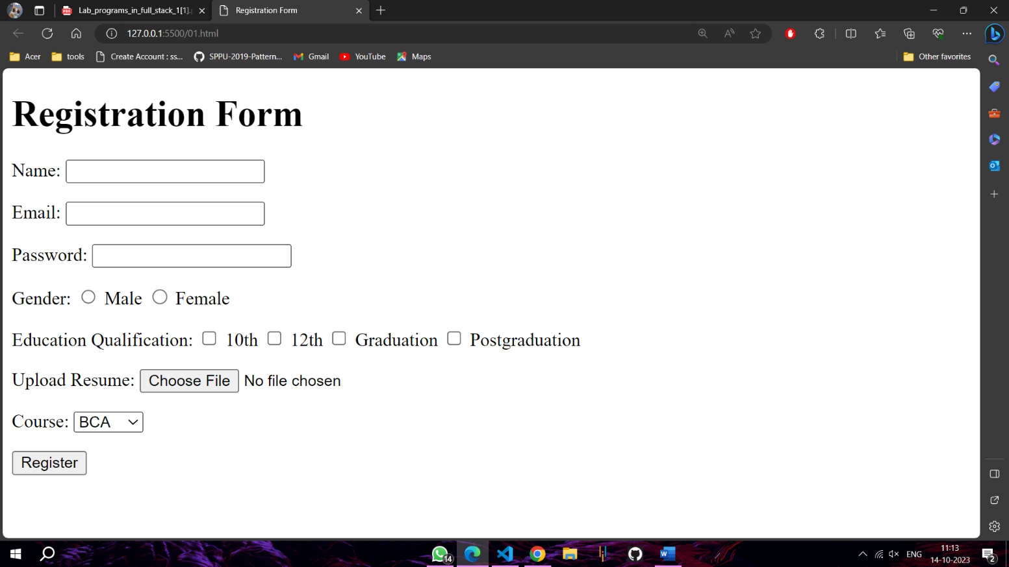

**PROGRAM 2**

NAME -Lalit singh

COURSE -MCA 1st Sem

ROLL NO -2351027

SUBJECT -Full Stack Development Laboratory (PMC-101)

**OBJECTIVE: To Design a web page for ordered and unordered list.**

**HTML CODE:**

<!DOCTYPE html>

<html>

<head>

<title>Ordered and Unordered Lists</title>

</head>

<body>

<h1>Ordered and Unordered Lists</h1>

<h2>Unordered List</h2>

<ul style="list-style-type: disc;">

<li>Item 1</li>

<li>Item 2</li>

<li>Item 3</li>

</ul>

<h2>Ordered List</h2>

<ol style="list-style-type: decimal;">

<li>Item 1</li>

<li>Item 2</li>

<li>Item 3</li>

</ol>

</body>

</html>

**OUTPUT:**

**PROGRAM 3**

NAME -Lalit singh

COURSE - MCA 1st Sem

ROLL NO -2351027

SUBJECT -Full Stack Development Laboratory (PMC-101)

**OBJECTIVE: To Design a web page for internal and external hyperlink.**

**HTML CODE:**

<!DOCTYPE html>

<html>

<head>

<title>Internal and External Hyperlinks</title>

</head>

<body>

<h1>Internal and External Hyperlinks</h1>

<h3>Internal Hyperlink</h3>

<p>This is an <a href="#anchor">internal hyperlink</a>.</p>

<h3>External Hyperlink</h3>

<p>This is an <a href="https://www.google.com">external hyperlink</a> to Google.</p>

<p id="anchor">

<h4>This is the anchor point for the internal hyperlink.</h4>

An internal hyperlink, also known as an anchor link, is a hyperlink that connects two pages within the same website. Internal hyperlinks are used to help users navigate through a website and to find the information they are looking for.<br>

Internal hyperlinks can be created using the <a> element in HTML. The href attribute of the <a> element specifies the URL of the page that the link will point to.

</p>

</body>

</html>

**OUTPUT:**

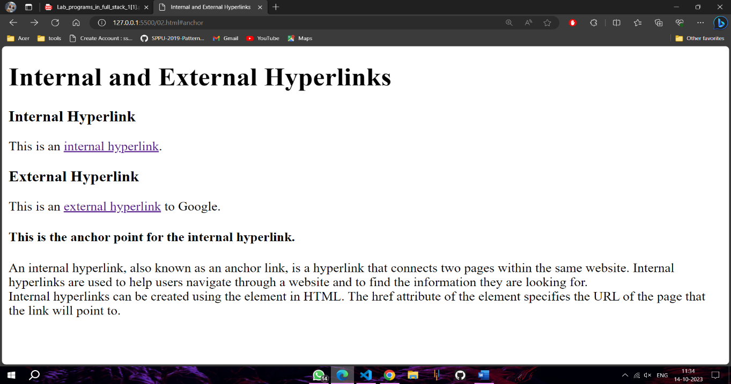

**PROGRAM 4**

NAME -Lalit singh

COURSE -MCA 1st Sem

ROLL NO -2351027

SUBJECT -Full Stack Development Laboratory (PMC-101)

**OBJECTIVE: To illustrate the use of 6 heading tags from<h1> to <h6> in html.**

**HTML CODE:**

<!DOCTYPE html>

<html>

<head>

<title>Internal and External Hyperlinks</title>

</head>

<body>

<h1>Heading Tags</h1>

<p>

The different heading tags produce headings of different sizes and font weights. The &lt;h1&gt; tag produces the largest and most important heading, while the &lt;h6&gt; tag produces the smallest and least important heading.

</p>

<ol>

<li><h1>This is the main heading</h1></li>

<li> <h2>This is a subheading</h2></li>

<li><h3>This is a sub-subheading</h3></li>

<li><h4>This is a sub-sub-subheading</h4></li>

<li><h5>This is a sub-sub-sub-subheading</h5></li>

<li><h6>This is the least important heading</h6></li>

</ol>

</body>

</html>

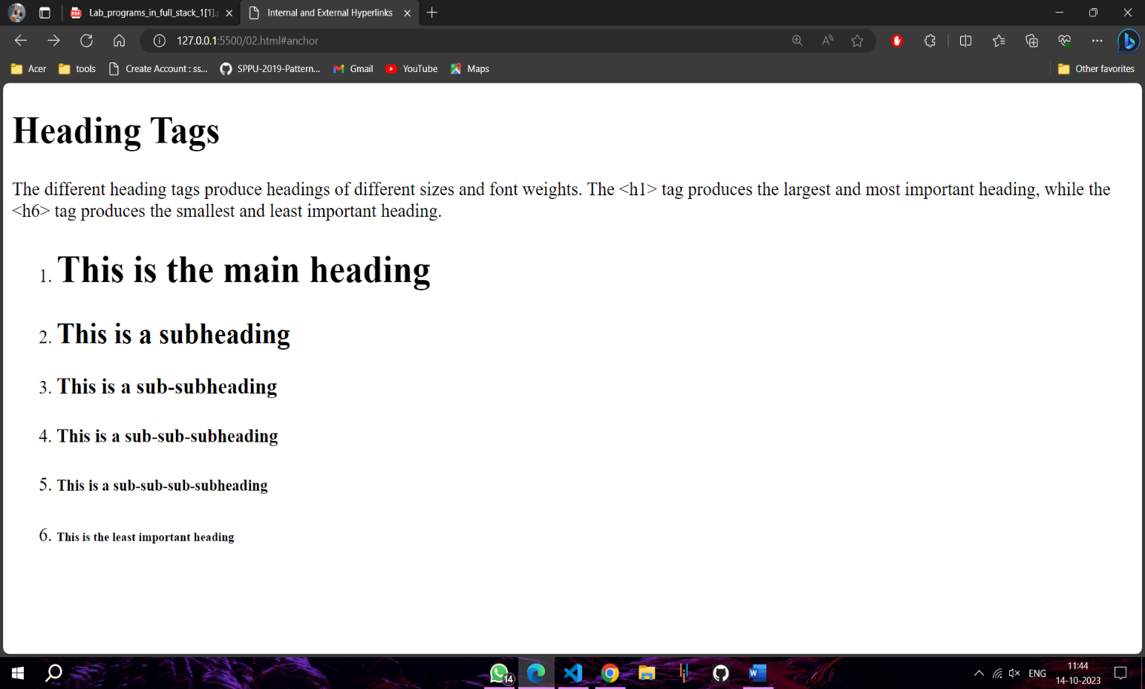**OUTPUT:**

**PROGRAM 5**

NAME -Lalit singh

COURSE -MCA 1st Sem

ROLL NO -2351027

SUBJECT -Full Stack Development Laboratory (PMC-101)

**OBJECTIVE: To Design a web page and demonstrate the use of image tag.**

**HTML CODE:**

<!DOCTYPE html>

<html>

<head>

<title>Image Tag</title>

<style>

img {

width: 300px;

height: 300px;

display: block;

}

</style>

</head>

<body>

<h1>Image Tag</h1>

<p>The image tag will display the image image.jpg and the alt text "This is an alt text".

The alt text is an important part of the image tag. It is a text description of the image that is displayed to users who cannot see the image. </p>

<img src="img1.jpeg" alt="This is an alt text">

<caption>This is an example of an image tag:</caption>

</body>

</html>

**OUTPUT:**

**PROGRAM 6**

NAME -Lalit singh

COURSE -MCA 1st Sem

ROLL NO -2351027

SUBJECT -Full Stack Development Laboratory (PMC-101)

**OBJECTIVE: To Illustrate the use of id selector in css.**

**HTML CODE:**

<!DOCTYPE html>

<html>

<head>

<title>ID SELECTOR</title>

<style>

#para1{

color: red;

font-size: 20px;

border: 1px solid black;

padding: 10px;

height: 200px;

width: 50%;

}

</style>

</head>

<body>

<h2>Id Selector</h2>

<p>id selector to style any element on a web page, including headings, paragraphs, images, and links. By using the id selector effectively, you can create a unique and consistent style for your web page.</p>

<p id="para1">This is a paragraph contain CSS With ID selector</p>

</body>

</html>

**OUTPUT:**

**PROGRAM 7**

NAME -Lalit singh

COURSE -MCA 1st Sem

ROLL NO -2351027

SUBJECT -Full Stack Development Laboratory (PMC-101)

**OBJECTIVE: To Illustrate the use of Class selector in css.**

**HTML CODE:**

<!DOCTYPE html>

<html>

<head>

<title>ClassSELECTOR</title>

<style>

.c1{

  color: red;

  font-size: 20px;

  border: 1px solid black;

  padding: 10px;

  height: 200px;

  width: 40%;

}

</style>

</head>

<body>

<h2>Class Selector</h2>

<p>

A class selector is used to select all elements with the same class attribute. To select elements with a specific class, write a period (.) character, followed by the class name.</p>

<p class="c1">This is a paragraph contain CSS through class selector</p>

<p class="c1">This is a paragraph contain CSS through class selector</p>

</body>

</html>

**OUTPUT:**

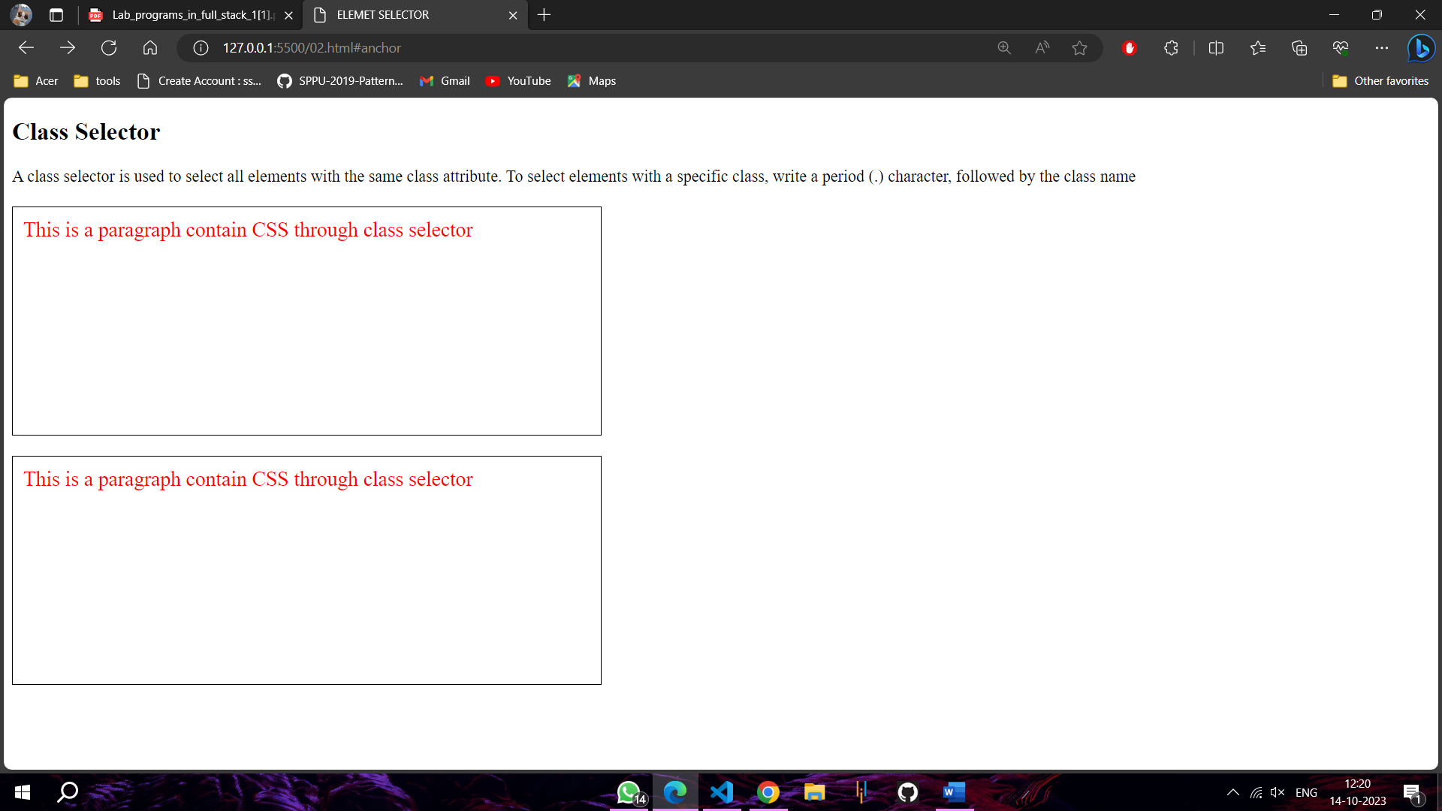

**PROGRAM 8**

NAME -Lalit singh

COURSE -MCA 1st Sem

ROLL NO -2351027

SUBJECT -Full Stack Development Laboratory (PMC-101)

**OBJECTIVE: To Illustrate the use of element selector in css.**

**HTML CODE:**

<!DOCTYPE html>

<html>

<head>

<title>ELEMET SELECTOR</title>

<style>

p{

color: red;

font-size: 20px;

border: 1px solid black;

padding: 10px;

height: 200px;

width: 40%;

}

</style>

</head>

<body>

<h2>Element Selector</h2>

<span> An element selector is used to select elements of a specific type</span>

<p class="c1">This is a paragraph contain CSS through element selector</p>

<p class="c1">This is a paragraph contain CSS through element selector</p>

</body>

</html>

**OUTPUT:**

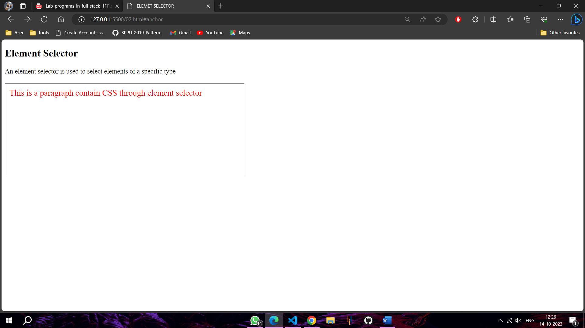

**PROGRAM 9**

NAME -Lalit singh

COURSE -MCA 1st Sem

ROLL NO -2351027

SUBJECT -Full Stack Development Laboratory (PMC-101)

**OBJECTIVE: To Illustrate the use of universal selector in css.**

**HTML CODE:**

<!DOCTYPE html>

<html>

<head>

<title>Universal Selector</title>

<style>

* {

color: red;

font-family: cursive;

}

</style>

</head>

<body>

<h1>Universal Selector</h1>

<p>The * selector in CSS is the universal selector. It selects all elements on a page, regardless of their type.</p>

<ul>

<li>This is a list item</li>

<li>This is another list item</li>

</ul>

<img src="img1.jpeg" alt="This is an image">

</body>

</html>

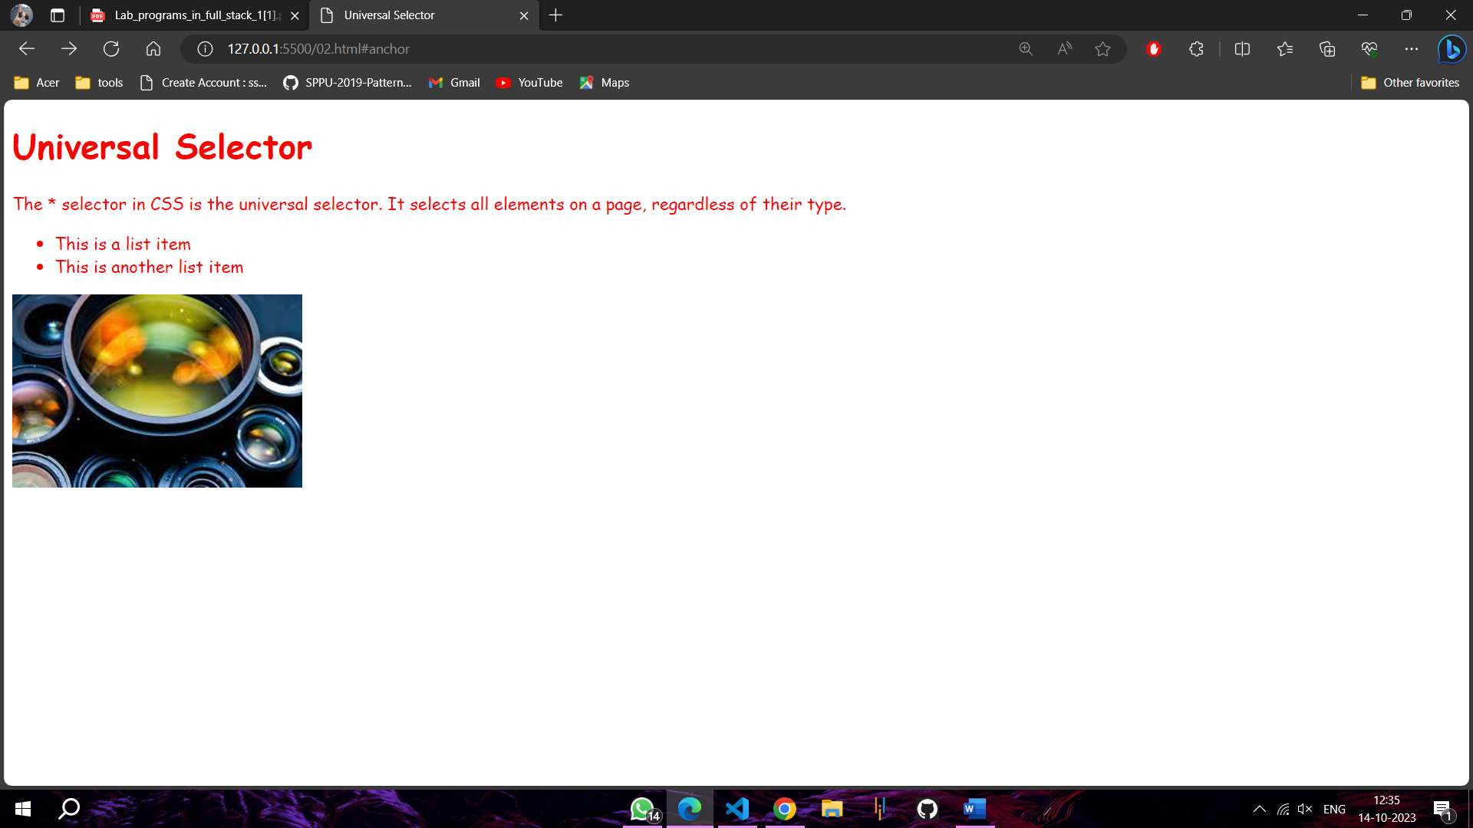**OUTPUT:**

**PROGRAM 10**

NAME -Lalit singh

COURSE -MCA 1st Sem

ROLL NO -2351027

SUBJECT -Full Stack Development Laboratory (PMC-101)

**OBJECTIVE: To Illustrate the use of active and hover pseudo class in css.**

**HTML CODE:**

<!DOCTYPE html>

<html>

<head>

<title>Active and Hover Pseudo Classes</title>

<style>

a {

color: blue;

}

a:active {

color: red;

}

button {

background-color: gray;

color: white;

padding: 10px;

}

button:hover {

background-color: yellow;

}

</style>

</head>

<body>

<h1>Active Pseudo Classes</h1>

<p>The active pseudo class is used to style an element when it is being clicked. This can be useful for providing visual feedback to users when they interact with your page.</p>

<p>This <a href="#">link</a> is example of active pseudo Classes </p>

<h1>Hover Pseudo Classes</h1>

<p>The hover pseudo class is used to style an element when the user's cursor is hovering over it. This can be useful for highlighting elements on your page and for providing users with more information about an element</p>

<p>This button <button type="button">Click Me</button> is example of hover Pseudo Classes</p>

</body>

</html>

**OUTPUT:**

